**CPH-TCP/IP reader connection instructions**

1. **Static IP address connection DEMO mode**
2. Reader factory parameter settings

|  |  |
| --- | --- |
| Module Static IP | 192.168.0.7 |
| Gateway | 192.168.0.1 |
| Module work mode | TCP Server |
| Local Port | 12345 |

As shown below: 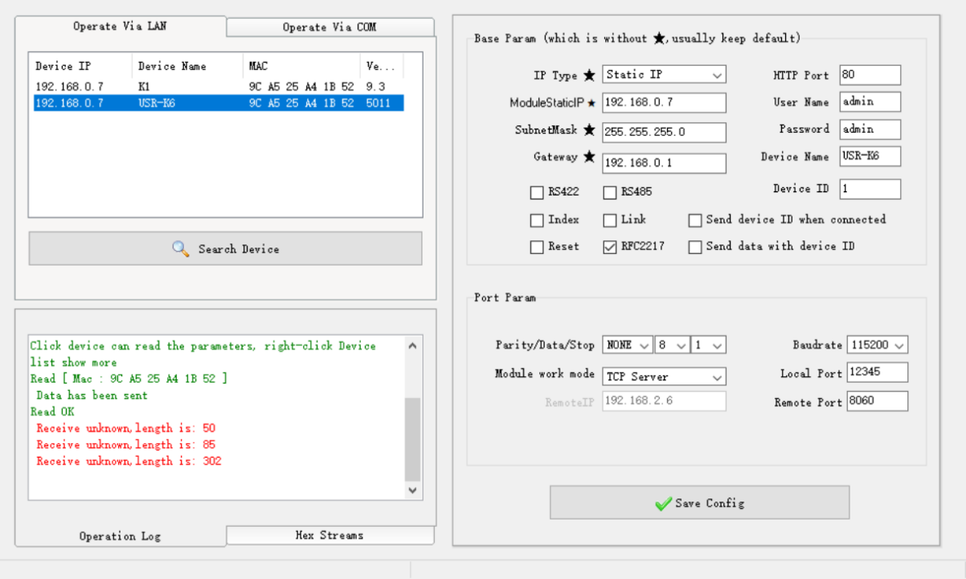

1. The Ethernet IP address of the computer and the IP address of the reader must be on the same network segment (subnet), otherwise the DEMO cannot be connected

Take the default IP address of the reader: 192.168.0.7 as an example:

1. Open the computer "Control Panel", select and open "Network and Internet", select and open "Network and Sharing Center", click "Ethernet", click "Properties", select and double-click to open "Internet Protocol Version 4 (TCP/IPv4)", select "Use the following IP address", and modify the IP address, subnet mask, and default gateway. As shown below: 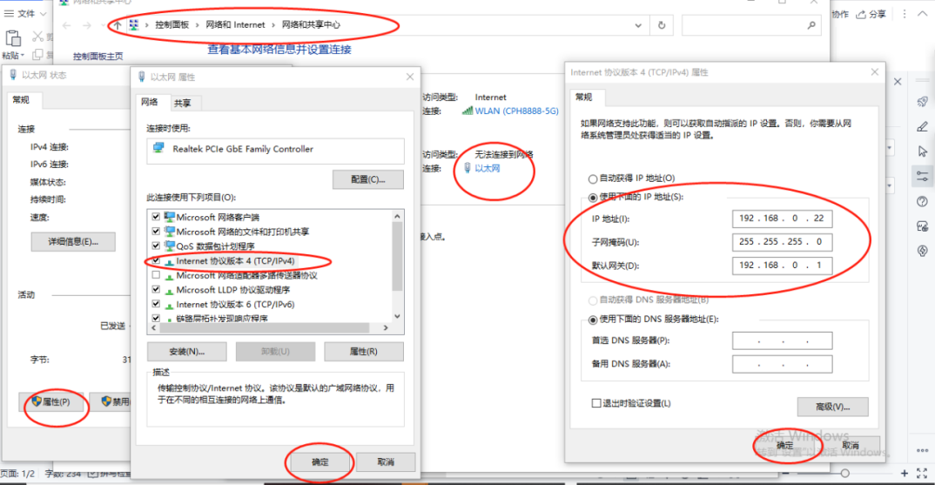
2. After setting the IP address and default gateway, click OK to automatically close the window, click the Ethernet Properties window to confirm, and the update parameters are completed.
3. Reader device runs DEMO software
4. Connect the power adapter to the reader and power on, connect the reader to the computer with a network cable, open the DEMO software, and select RJ45 in the interface item.

As shown below:

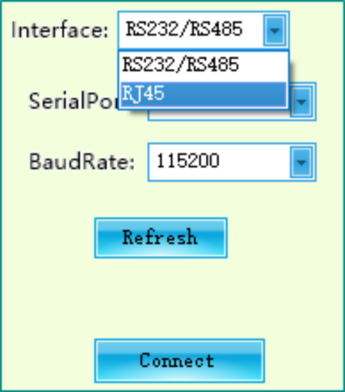

1. Enter the RJ45 parameter page, the reader IP: 192.168.0.7, the reader address (DEMO displays an error, the reader address is actually the local port number): 12345, the network protocol: TCP Client, click the Connect button to connect the demo.

As shown below:

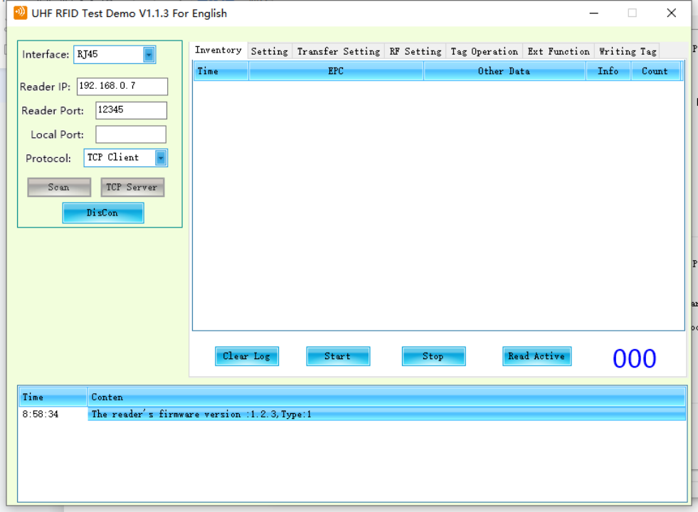

1. **Dynamic IP address connection DEMO method:**
2. When using the LAN, connect the network port reader to the power supply and power on, use the network cable to connect the network port reader to the router port, use the network port tool to click "Search Device", and change the network port "IP address type" to "DHCP/Dynamic IP", click the Save Config button.

As shown below: 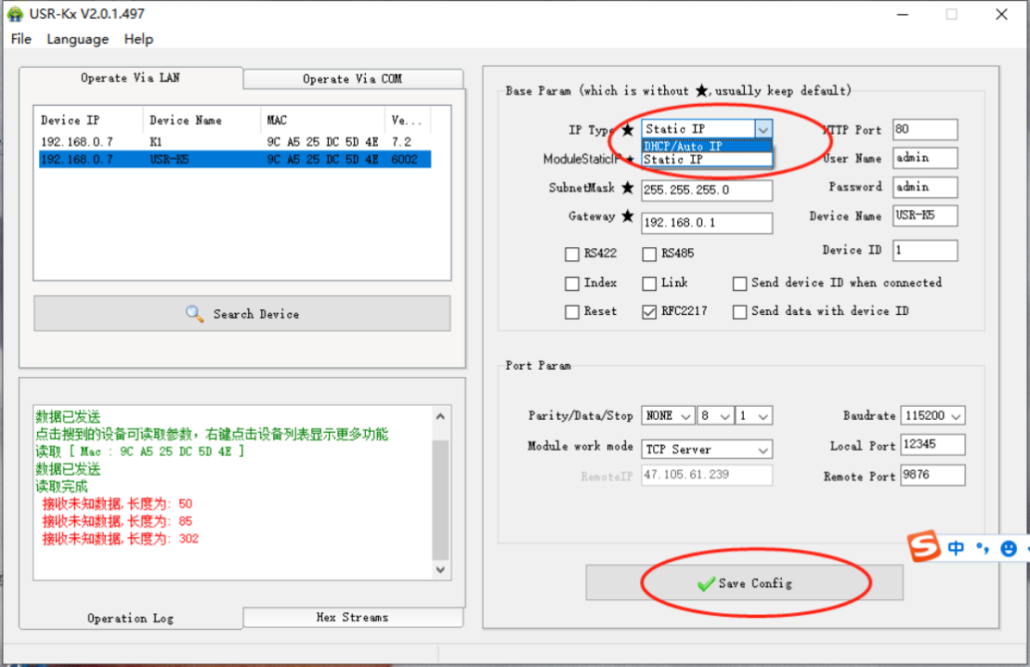

1. Then click the Search Device button, the dynamic IP address will appear.

As shown below: 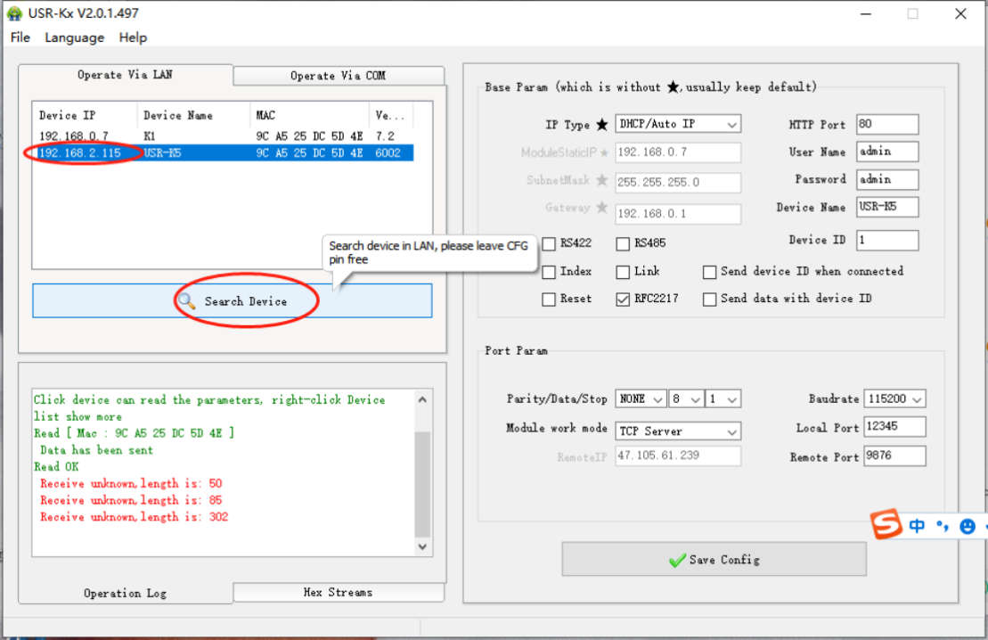

1. Use dynamic IP to connect DEMO.

As shown below: 